Culturally Nepal (Website)

Proposal



Prepared by: Anjela Shahi Newa

ID: 00174641

Computing Project

L5DC

Softwarica College of IT and E-commerce

# Ch-1

# Introduction

My project ‘Culturally Nepal’ is going to be about a website that spreads the idea of Nepalese cultural background. It will knowledge the people about the different kinds of cultures Nepalese people follow. It guides the visitors about what to do, what to see and where to be when they are in Nepal.

# Background of the project

So, basically the project is all about the information provision. To those who are visiting Nepal, it will be one of the good choices to look up for some ideas about what is going on. Besides that the project will also have some additional features like the suggestions for the places to visit or the special things to do while here.

# Problem statement

Project statement is an important topic as it defines what the problems may be and how it may impact as an effect. As it is said “The formulation of the problem is often more essential than its solution”.

**Time Management-**

Time management can be a problem when completing a whole project by an individual person.

**Product quality-**

The quality definition depends from person to person. All and everyone cannot be satisfied with the same feature of the product so it can be a problem.

**Undesirable outcome-**

Ideas and concepts keep on changing. While developing the website, what was desired at the beginning may not feel as pleasing and can come out as an undesirable outcome.

# Description of the project

The project is going to be about the website that shows or list outs the cultures of Nepal. Every list is going to have its own description. People can learn about the different festivals the natives celebrate with the corresponding pictures. It will have its own photo gallery kind of section. People can get the idea for their next visit area. The recommendation will be listed too.

# Features

1. Places to visit
2. Different kinds of activities
3. Different kinds of cultures followed in Nepal
4. Main attractions
5. Dates of the events etc.

# Overview

This includes the introduction about the project. The background, showing what the project is actually conceptualized. All the problems that could be faced in the coming phases are listed. The features of the project. What the users could find in the website. To summarize, This section includes the background of the project to be developed.

# Ch-2.

# Scope

The project ‘Culturally Nepal’ is an information and travel aid based website. So the scope of this project is to deliver the cultural based knowledge about Nepal. A page including the main attractions of Nepal. Page including the things the travelers can do while in here. Jutras and festivals page that redirects the users to their details. Also a photo gallery on the same topic.

# Limitation

I will try to make this project as clean as possible but it will not have all the features like:

1. Tracking the location
2. Maps
3. Planning the trip etc.

# Aims

As every project must have an aim. This project is also based on the aim to-

1. Design a beautiful website that includes at least minimum knowledge about the Nepalese cultural and natural beauty.
2. The must visit page to help travelers with their next destination.

# Objectives

Objectives are followed to achieve the aims. The objectives of this project are as follows-

1. Analyzing the project.
2. Listing out the essential subjects for the website.
3. Information about all the places to list are to be collected.
4. Planning the tasks. How and what should be done.
5. Designing the website according to the plan.
6. Managing the time.
7. Researching about all the things to do (e.g. Bungee jump).
8. Listing out the cultures Nepal is famous for.
9. A good design pattern must be followed.
10. Proper follow up of the development methodology should be done.
11. Testing for any error for codes to reduce them.

# Overview

The project’s scope is to deliver the knowledge to the users about Nepalese culture. Little similar to the tourist guide concept, it guides the people about where to travel and what to watch next. This section is about the limitations of the project. The aim it holds and the objectives that are followed to achieved it.

# Ch-3 Development methodology

# Description of the methodology chosen

There are many kinds of methodology but for this project I am choosing waterfall model. This is an individual project so, waterfall methodology is the best suited. Some of reasons to choose this methodology are as follows-

* Requirements are very well known, clear and fixed.
* Technology is understood.
* Requirements are free to choose and not difficult
* Enough resources with required skills are available freely
* The project is short.

Regarding the above points, our project requirements are also clear. Technology is understood. Our requirements and ideas are free to choose so it would not be so difficult. Since, this an individual project, resources available now are enough. This can be considered as a small project since it is being completed in less amount of time and an individual developer. Since all the reasons to use this methodology match this project, it is the best and suitable option for the development.

Advantages of Waterfall methodology

* Simple and easy to understand and use.
* Phases are completed one at a time.
* A schedule can be set with deadlines for each stage and a product can proceed through the development process.
* The start and end points are fixed so, the progress can be measured.

Comparing the waterfall methodology with other methodology.

|  |  |  |
| --- | --- | --- |
| **S.N** | **Waterfall methodology** | **Agile methodology** |
| 1. | It is a structured development method and can be rigid at times. | It is known for its flexibility. |
| 2. | It suites the project whose requirements are clearly defined. | Requirements may change according to the situation. |
| 3. | The changes cannot be made as the process is sequential. | It allows changes to be made since it starts with a simple design. |
| 4. | Testing is done at the end of the project. | Testing is done during the development cycle. |
| 5. | Mostly used for small projects or individual development. | It needs large number of participants. |

Since, our project has a fixed requirements and is also an individual task, it is more reasonable to use waterfall methodology over agile.

The phases/stages of waterfall model are described below-

# 

Fig 1: Waterfall Model

**Requirement analysis**

It can be known as the understanding of the exact necessity to develop the product. The requirement of the system is analysed about what it should be and how it should work.

**Design**

Planning the programming languages to be used. About the database system to be used. All the requirement analysis are taken into mind, studied and then the design is prepared. Sketching the designs about how it should look.

**Implementation**

The design that was visioned is now implemented into coding. All the designing of the product is done in this stage.

**Testing**

This stage is about testing the product and checking for the bugs. It is also done to verify if the product developed works according to the requirement specifications or not.

**Deployment**

Finalized product is then deployed in the respective field or environment.

**Maintenance**

It is done after the release. Issues keep on arising and should be fixed to keep it maintained. Important updates to the site must be done.

# Design pattern

I have chosen MVC design pattern for this project. The model-view-controller (MVC) is a design pattern that shows that an application consist of a data model, view information, and control information. Each of these needs to be separated into different objects. It does not show how a data is presented to a user.

The view presents the model's data to the user. The view knows how to access the model's data, but it does not know what this data means or what the user can do to manipulate it.

Finally, the controller stays between the view and the model. It listens to events given by the view and executes the appropriate reaction to it.

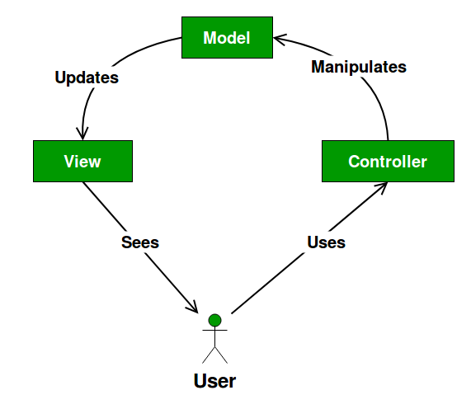

Fig 2: MVC design

Advantages of MVC

* Can provide multiple views.
* It is a faster development process.
* Works well for developing web applications.
* The modification does not affect the entire model.

# Architecture

Client server architecture of a computer network in which many clients (remote processors) request and receive service from a centralized server (host computer). Client computers provide an interface to allow a computer user to request services of the server and to display the results the server returns.

|  |  |  |
| --- | --- | --- |
|  | **Client-server architecture** | **Peer-to-peer architecture** |
| 1. | Specific client is connected to specific server. | Clients and server is not divided. |
| 2. | It is more stable than peer-to-peer. | It suffers if the number of peers increases in the system. |
| 3. | The data is stored in the centralized system. | Each peer has its own data. |
| 4. | It is focused on sharing information. | It is focused on connectivity. |
| 5. | It can be used by big organizations too. | It is used for only small business. |

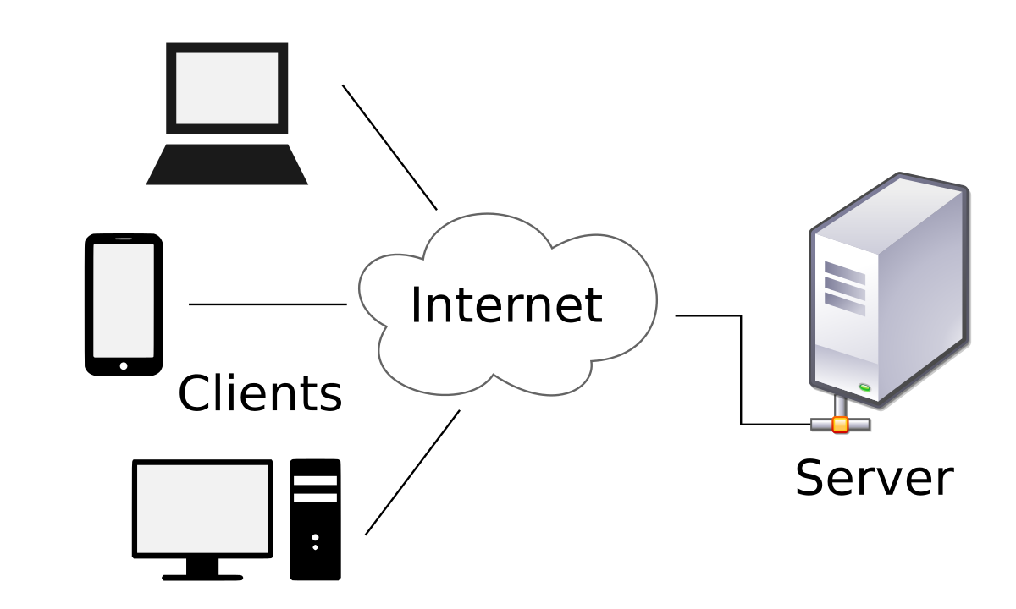

Fig 3: Client-server architecture

# Ch-4 Project Planning

# WBS

It is used to break down the project into small tasks. Work breakdown structure (WBS) is a hierarchical tree structure used to outline the project and breaks it down into smaller portions which is more manageable. Breaking it down into smaller events means the work can be finished sequentially in the respective time frame.

Following are some reasons to create WBS-

* It makes the project accurate and readable.
* Helps to estimate the time and risk.
* Increases the productivity
* Better progress monitoring.
* Detailed steps are shown.

Fig 4: WBS tree structure Milestone

|  |  |  |  |  |
| --- | --- | --- | --- | --- |
| **S.N.** | **Project task** | **Starting date** | **Ending date** | **Number of days** |
| 1. | **Proposal** | **Mach 25th 2019** | **April 9th 2019** | **16** |
| 2. | **Analysis**   * Requirement * Use case * Brainstorming * Architecture | **April 10th 2019**  April 10th 2019  April 20th 2019  April 25th 2019  May 5th 2019 | **May 8th 2019**  April 19th 2019  April 24th 2019  April 30th 2019  May 8th 2019 | **29**  10  5  6  8 |
| 3. | **Design**   * Structural Model * Designing database * Behavioral model | **May 9th 2019**  May 9th 2019  May 17th 2019  May 26th 2019 | **June 3rd 2019**  May 16th 2019  May 25th 2019  May 3rd 2019 | **26**  8  9  9 |
| 4. | **Implementation**   * Initiation * Planning * Coding | **June 4th 2019**  June 4th 2019  June 5th 2019  June 7th 2019 | **June 24th 2019**  June 4th 2019  June 6th 2019  June 24th 2019 | **21**  1  2  18 |
| 5. | **Testing** | **June 25th 2019** | **July 1st 2019** | **7** |
| 6. | **Reporting** | **July 2nd 2019** | **July 17th 2019** | **11** |

Milestones are important to keep the track of the tasks. It helps to finish the project in the determined time and thus be more productive.

In the above milestone table

# Gantt chart

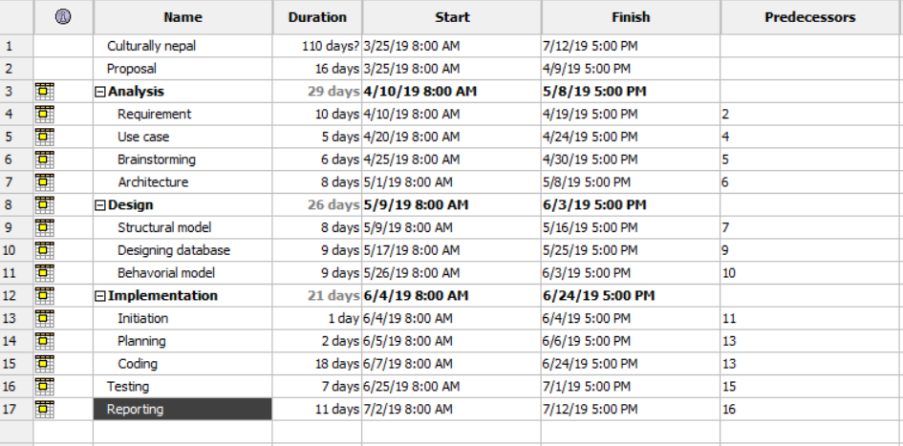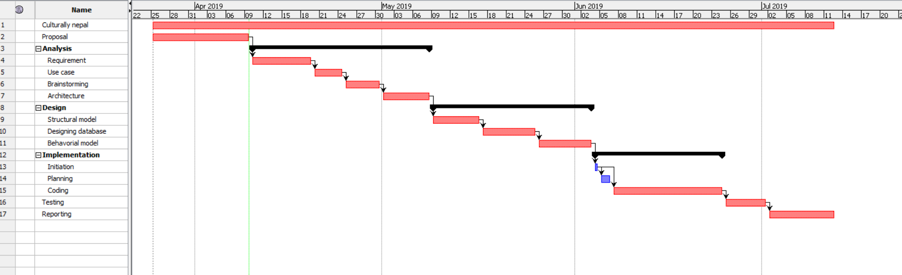

# Ch-5 Risk management

Impact= likelihood * consequences

|  |  |
| --- | --- |
| **Likelihood** | **Value** |
| Low | 1 |
| Medium | 2 |
| High | 3 |

|  |  |
| --- | --- |
| **Consequences** | **Value** |
| Very low | 1 |
| Low | 2 |
| Medium | 3 |
| High | 4 |
| Very high | 5 |

|  |  |  |  |  |  |
| --- | --- | --- | --- | --- | --- |
| **S.N** | **Risks** | **Likelihood** | **Consequence** | **Impact** | **Measures** |
|  | Time manage difficulty | 2 | 5 | 10 | Work should be done according to the divided time schedule |
|  | Code errors | 3 | 4 | 12 | Errors must be debugged while it is still small |
|  | Hard disk failure | 1 | 5 | 5 | Cleaning the disks |
|  | Misunderstood requirements | 1 | 4 | 4 | Set up the clear vision in the beginning |
|  | Health factors | 2 | 4 | 8 | Health care |
|  | Loss of data | 2 | 5 | 10 | Backup plans like copying the file in different medias |
|  | Competition | 1 | 2 | 2 | Keeping the idea as unique as possible |
|  | Natural disaster | 1 | 3 | 3 | Data backup |

# Ch-6 Configuration management

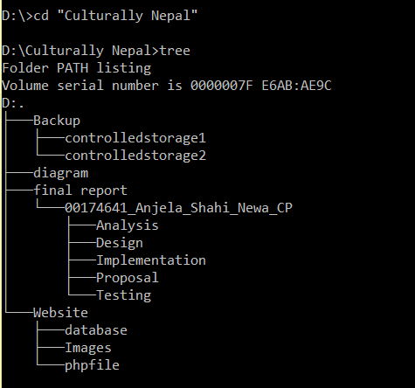s

Fig: Tree structure of folders

# Ch-7 Conclusion

The primary goal of this project is to attract the users into the unique cultures of Nepal. Not only that there are a lot of sites that is a must seeing while still alive. To succeed this idea, we have discussed about our main vision, the development methodologies for it, suitable design pattern, milestone and Gantt chart to work along with the schedule and finish it on time. We are initiating the project from April 10th 2019.

# Ch-8 Reference and bibliography

Anon., 2007. *Tech target.* [Online]   
Available at: https://searchcio.techtarget.com/definition/project-scope  
[Accessed 2019].

Anon., n.d. [Online]   
Available at: https://bmtoolbox.net/wp-content/uploads/2016/05/Tool_30_mvp.jpg

Anon., n.d. *livity.* [Online]   
Available at: https://lvivity.com/waterfall-model